Please complete and return by mail the agreements and order forms attached below. If you have any questions or problems launching the attachments please contact the CBOE via email at: tickerxpress@cboe.com.

Return Address for Documentation:
CBOE
C/o Pete Smith
Ticker Express Documentation
400 S. LaSalle
Chicago, IL. 60605

Network Provider Agreement
This document is to be completed by the Network Provider that will provide connectivity between Ticker Xpress and the Member Computer Devices. Please return two signed copies.
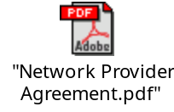

Market Data Agreement for Member Computer Devices
This document is to be completed by the Member or Member Organization that will be utilizing the computer. Please return two signed copies.
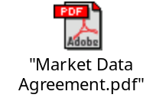

NASDAQ Subscriber Agreement
This document is to be completed by the Member or Member Organization that will be utilizing the Member Computer Devices. Please return two signed copies.

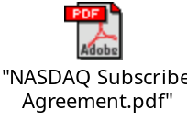

Ticker Xpress Order Form
This document is to be completed by the Member or Member Organization that will be utilizing the Member Computer Devices and the Network Provider that will be providing your connection to Ticker Xpress.

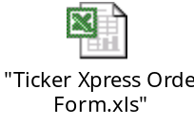
Cost
The monthly cost of Ticker Xpress will be $250.00 per User (Handheld).

